
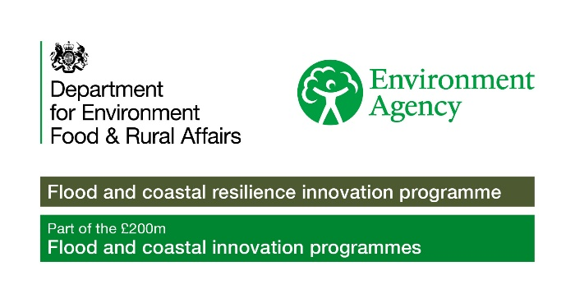

Stronger Shores Community Grants
Declaration
Before completing this application, you should read the Stronger Shores Community Grant guidance document, the terms and conditions, and the evaluation form. If you need any assistance, please contact strongershores@southtyneside.gov.uk.
Declaration
- I have read, understood, and accept the funding criteria and guidance document and the terms and conditions that accompany this application form. I agree that Stronger Shores can check the information in it and any supporting documents with other people and organisations.
- My organisation or community group has the power to accept a grant, under your terms, and the power to pay back the grant if the terms are not being met.
- I understand that any misleading statements (whether deliberate or accidental) I give at any point during the application process, or any information I knowingly withhold, could mean my application is not valid. Stronger Shores will cancel the grant and claim back any money they have provided, return the application, or withdraw any grant offered to your organisation.
- I am authorised to put forward this application on behalf of my organisation / community group.
- On behalf of my organisation / community group, I agree that if we receive any grant from Stronger Shores for our project, we will keep to the standard terms of the grant and any further terms and conditions set out in the grant notification letter.
Signature:

Name:

Organisation/ Community Group:
Position:
Date:

Please send the completed application form to: strongershores@southtyneside.gov.uk

