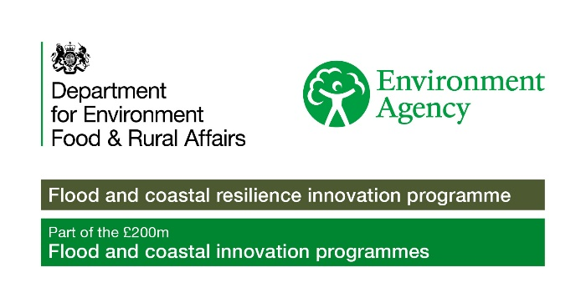


Stronger Shores Community Grants
Terms and Conditions
This document sets out the terms and conditions for the Stronger Shores Community Grants Scheme. Please read the terms and conditions carefully and keep a copy of this document, as well as the grant offer, for reference. You should also share them with the people responsible for managing your organisation’s finances and funded activities. If you do not wish to agree to the terms and conditions, please tell us immediately and we will withdraw the grant offer.
In this document ‘you’ and ‘your’ means the organisation we have offered a grant to and ‘we’ and ‘our’ means Stronger Shores.
Purpose of the grant
- You must only use our grant for the purpose you applied for unless otherwise agreed. You must tell us if:
  - You want to do something different with the grant
  - You cannot use all or part of the grant within the agreed time scale stated in the grant offer
  - You receive funding from elsewhere which duplicates our grant.
- In any of these cases, you may have to repay some or all of our grant unless we approve a change in writing.
Evaluation and record-keeping
- You must provide feedback within 6 months of grant completion. An evaluation form will be sent to you when the grant is offered.
- You must keep a record of your spending. This includes receipts or invoices for anything you purchase with our grant. We must be able to see these at any reasonable time during the period of our grant and up until March 2027 (or another period we agree). You must send us a copy of your most recent annual financial statements if we request them.
- We may visit your organisation to see and discuss the work we have funded and to see evidence of how you spent the grant and understand the difference our funding made.
- We may share information you give us with relevant organisations (e.g. the police or Charity Commission) if appropriate during any investigation.
Paying the grant
- Grants will be paid as a one-off payment within 30 days of the grant offer being accepted.
- Payments will be made to the account you have provided on your application. You must notify us if your bank details change.
Acknowledgements and publicity
- You must acknowledge us in any press release, publication or promotional material about the work we fund. Any press releases should be signed off by us before they are published.
- You must include our logo and the Flood and Coastal Innovation Programme logo on all promotional material.
- Where word count allows, you should include the following funding statement “This project is funded by the Stronger Shores Community Grant scheme. Stronger Shores is a project funded by Defra as part of the £200 million Flood and Coastal Innovation Programmes which is managed by the Environment Agency.”
- We will include the grant in data we publish. We will contact you in advance if we want to publicise your grant. We will get your permission before commissioning photographs of the activity we fund or using photographs you have given us.
Your responsibilities
- You must do the following:
- Fulfil your purpose and responsibilities as set out in your governing document.
- Meet all your legal and regulatory obligations, including making sure you continue to have adequate safeguarding arrangements in place.
- Have any necessary permissions and adequate insurance, and ensure you store any equipment funded by our grant safely and securely.
- You must tell us in writing of any significant development affecting your whole organisation, or the work we have funded. This includes the following situations:
- If you change the main contact for our grant.
- If you dismiss or remove your Chair or Chief Executive, or the key staff responsible for work we have funded.
- If you have financial or cash flow problems, or any incident of fraud.
- Any other matter concerning your organisation that is reported to the police, Charity Commission or another regulatory or safeguarding authority.
Equal Opportunities
- Stronger Shores is committed to promoting equal opportunities.
Use of Personal Data and GDPR
- Stronger Shores will use the personal information about you and other named individuals provided in your application to assess and administer a grant application for the Stronger Shores Community Grants Scheme.
- To support this, searches may be carried out using publicly available sources such as the Charity Commission website.
- Under GDPR regulations, your information will only be used where Stronger Shores has a legal basis to do so, for example, to carry out our legitimate interests to manage and promote our Community Grants Scheme, or to meet our legal or contractual obligations.
- By providing any personal information about another person, you are confirming that they understand how their data may be used and shared. When it comes to your personal data, under GDPR Regulations, you have certain rights. This includes rights to access and correct your information, and to erase, transfer, object to, restrict or take away consent around how we use your information.
- You should contact Stronger Shores if you or anyone named in your application have any concerns with the information being used publicly or if you wish to exercise any of your rights.
Intellectual Property Rights (IPR)
- Stronger Shores will retain all IPR on grant outputs.
Withdrawal or reclaim of grant
- We may withdraw the grant offer, or we reclaim all or part of a grant paid, in any of the following situations.
- If you do not comply with these terms and conditions.
- If you knowingly withhold information.
- If you give false information to us in your application or about your grant.
- If an investigation by the Charity Commission, police or another regulatory or safeguarding body identifies serious concerns about your organisation.
- If, in our opinion, your actions conflict with our policies or damage our reputation.
- If your organisation becomes insolvent, goes into administration, receivership or liquidation, you must contact us immediately. If our grant or any part of it has not already been spent on the agreed purpose, you must return it to us.
- If your organisation decides to merge with another group during the period of our grant, you must contact us immediately. We may consider transferring the grant to the merged organisation subject to it being eligible for our funding.

