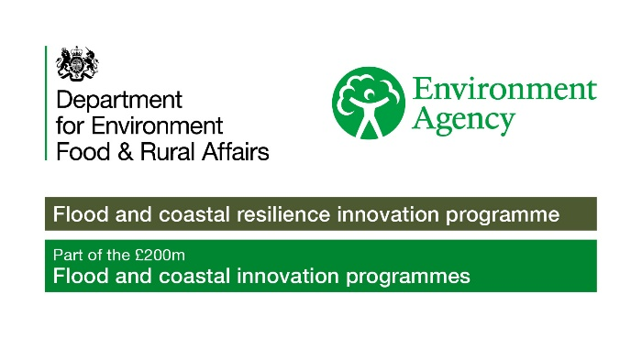


Stronger Shores Community Grants
Funding Criteria and Guidance
Stronger Shores is a project covering the North East of England coastline, from Northumberland to Redcar and Cleveland. We are learning how underwater habitats such as seagrass meadows, kelp forests, and native oyster reefs can naturally protect our coastlines from erosion and flooding, improve water quality, and create habitats for wildlife. We also believe that a healthy coastal and marine environment means a more beautiful place where people will want to live, work, and visit.
Community Grants
The Stronger Shores Community Grant scheme aims to support projects that will make a positive difference to the marine environment in the North East of England.
Size of Grant
£500 to £5,000.
What type of projects can be funded?
We want to support a broad range of projects that are community led and support the Stronger Shores mission of understanding how natural marine habitats can protect our coastline.
We want communities and their people to be part of this by building understanding of underwater habitats (seagrass, kelp, and native oysters), how the coastline is changing with the climate crisis, and what action individuals and groups can take to help protect the marine and coastal environment.
Funding can be for new or existing projects and activities which do one or several of these things:
- Help people learn about the marine and coastal environment where they live, and how underwater habitats such as kelp, oysters, and seagrass, help to protect our coastlines.
- Involve people in looking after and protecting marine and coastal habitats so they in turn better protect us.
- Explore how the marine and coastal environment is changing due to the climate crisis and what local action can be taken against this.

Additional grant criteria
- Projects and activities must take place in Northumberland, North Tyneside, South Tyneside, Sunderland, Durham, Hartlepool, or Redcar and Cleveland.
- Stronger Shores must fund over 50% of the total project costs.
- All funded projects should have an element of community engagement.
- Projects need to demonstrate how they link to the Stronger Shores vision.
- Projects should be completed within 12 months of the grant offer.

What can be applied for?
The following list indicates what can be applied for but may not include everything.
- Small items and equipment
- Costs of engagement sessions e.g workshops
- Transport costs
- Trips and excursions
- Learning activities
- Art and creative activities
- Citizen science and research
Who can apply?
- Constituted Community Groups
- Registered Charities
- Charitable Incorporated Organisations
- Parish and Town Councils
- Schools
- Registered social enterprises, CIC’s, companies limited by guarantee that have been registered for at least 12 months
- Other not-for-profit businesses (as evidenced in your Articles of Association) with charitable aims
- All applicants must have at least three unrelated management committee members or Company Directors
- Applicants must have a bank or building society account in the name of the organisation with at least two unrelated signatories. If this is not in place then another organisation, such as a Community Voluntary and Action Service, can accept the funding on behalf of your group.
Who can’t apply?
- Individuals
- Community groups without a constitution
- Statutory Organisations
- Organisations subject to an investigation in any legal capacity
What can’t be funded?
- Capital and building works
- Legal and/or statutory responsibilities
- Costs for any activity/project that has taken place before a grant is awarded
- Fundraising and sponsorship
- Campaigning and party-political activity
- For profit or commercial activity
- General contributions to large projects or fundraising appeals
- Purchase of a vehicle including boats
- Projects or activities that do not clearly link to the Stronger Shores project and community grants aims outlined above
- Projects and activities of personal or individual benefit
- Organisation start-up costs
How to Apply
Applications must be made using our grant application form.
Application Deadlines
You can apply from:
- 11th November 2024 to 13th January 2025.
We will aim to let you know if your application has been successful within 12 weeks.
Supporting Information
Please send the following information with your application:
- A copy of your governing document. For example, a constitution, rules, memorandum or articles of association.
- A copy of your most recent annual accounts no more than 18 months old.
- A copy of a bank statement no more than 3 months old. The statement must be in the name of the group or organisation applying for, or receiving, the grant.
- Organisational policies relevant to your project. For example, Safeguarding Policy if your project involves children, young people and/or vulnerable adults.
- Quotes for any items or services costing more than £500.
Selection process
- All applicants will be checked to ensure they meet the criteria and will be assessed on their own merit.
- The Community Grants Panel, made up from 4 representatives from different Stronger Shores Delivery Partners, will make recommendations on whether a grant should be offered. Feedback will be provided to unsuccessful applicants.
- A decision will be made within 12 weeks after the closing date for applications.
Other Documents
- Stronger Shores Funding Criteria document.
- Terms and Conditions.
- Evaluation form.
Any Questions?
If you have any more questions or would like to talk about your project idea, please contact Emily Ross on:
Email: strongershores@southtyneside.gov.uk
Phone number: 07976 074151

