
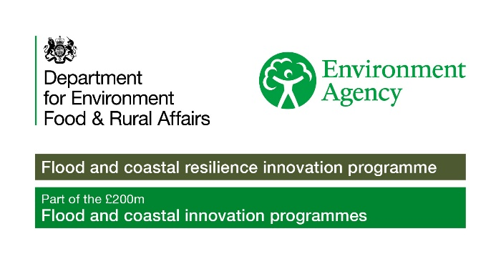

Stronger Shores Community Grants
Evaluation
Organisation details
Name of organisation / community group:

Address of organisation / community group: (including postcode)

Details of main contact person: |  | Name:  Position:  Address:  Contact number:  Email:
Name of your Project:

When did your project start and finish? |  | Start date:  Finish date:
Where did your project take place?
Please tick below.
Northumberland |  |  | North Tyneside
South Tyneside |  |  | Sunderland
Durham |  |  | Hartlepool
Redcar and Cleveland

Evaluation
Please provide a summary of your project, including the following:
- What did your project do?
- Did your project achieve everything it wanted to?
- What worked well?
- What could have worked better?
- Did you need to change anything?
- What is the one thing you would do differently?
- What has been the biggest impact?
- Do you plan to continue your project in any way?
Suggested word count 250-500 words. Maximum word count 1,000 words.

Please tell us about the people who have engaged with your project, including the following:
Total number of people engaged:
Demographics of people engaged (age, gender, ethnicity, disability)

Total number of volunteers (if any):

Total number of staff (if any):

If any volunteers were involved in this project, please tell us about the role that volunteers have played and how has this benefited both the volunteers and your project?

We would love to hear from anyone who has taken part in this project! Please add some quotes below from participants below:
Name | Age | Quote

We would love to see some photos from this project! Please add some photos and a short description of the photo using the space below.

